 SRI LANKA INSTITUTE OF INFORMATION TECHNOLOGY

[**Enterprise Standards and Best Practices for IT Infrastructure**](http://courseweb.sliit.lk/course/view.php?id=137)

**4th Year 2nd Semester 2016**

Name: L.V.Rajapaksha

SLIIT ID: IT13146498

Group Number:

Practical Session: WD

Practical Number : 1 and 2

Date of Submission: 2016/07/30

Date of Evaluation : _____________________

Evaluators Signature : _____________________

**Creating AWS linux instance**

1. Login to the aws account.
2. Select EC2 (virtual services in the cloud)

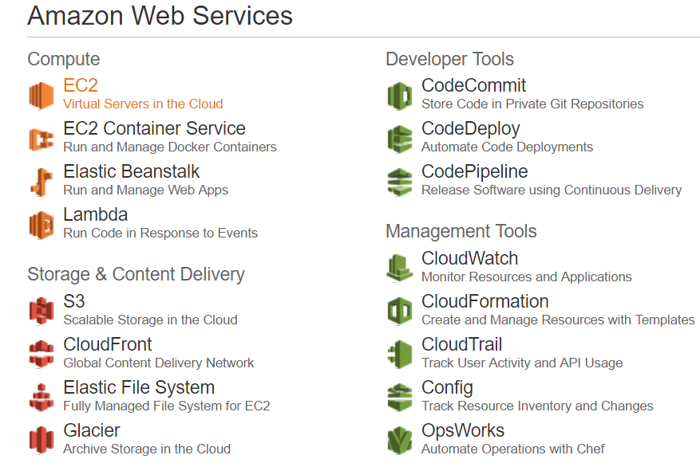

1. Select instances under instances from the left hand side menu

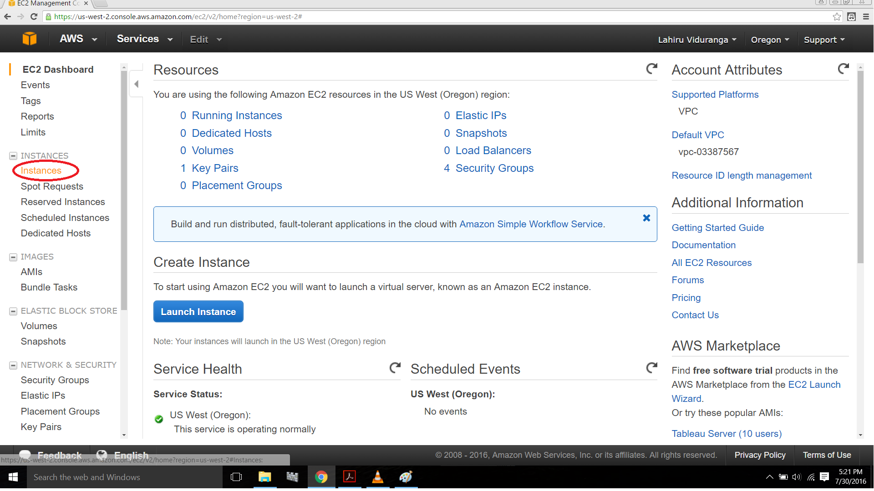

1. Now click on “Launch Instance”

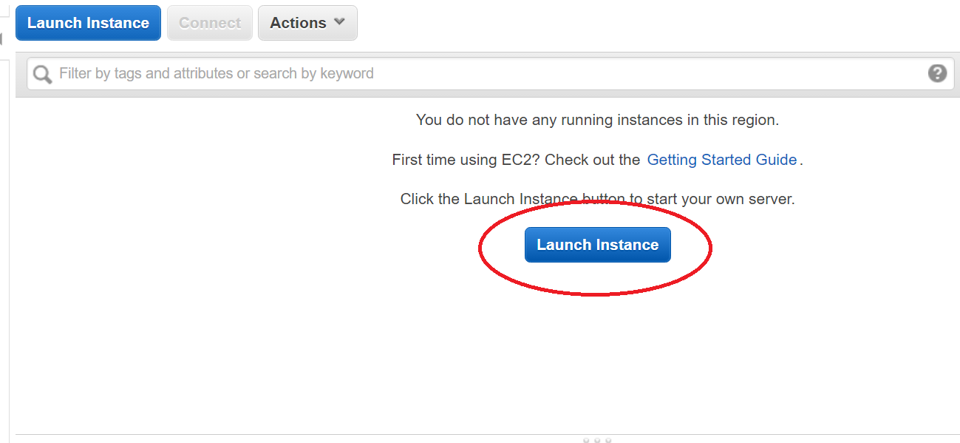

5.

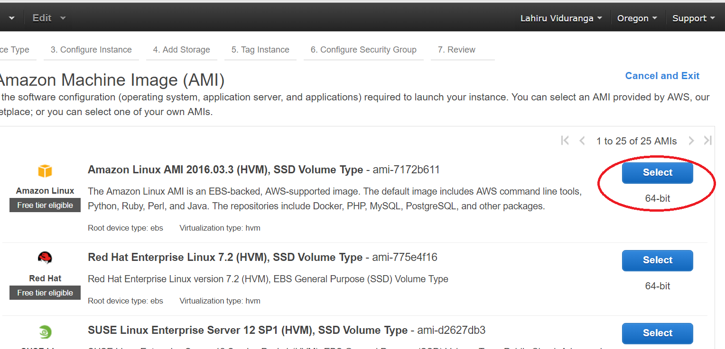

6

1. Click on “next”

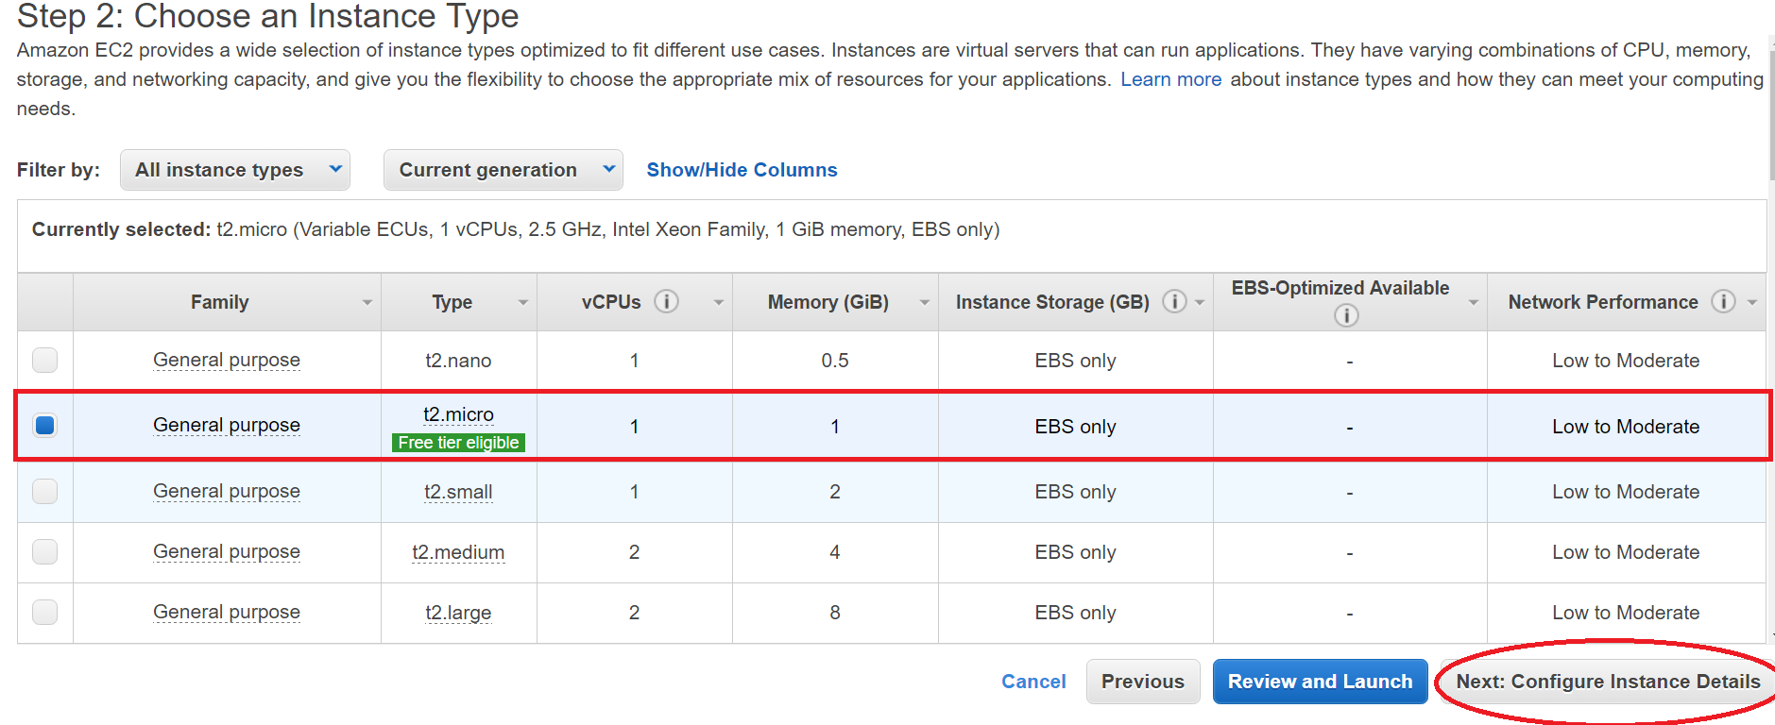

1. Select the subnet and click next

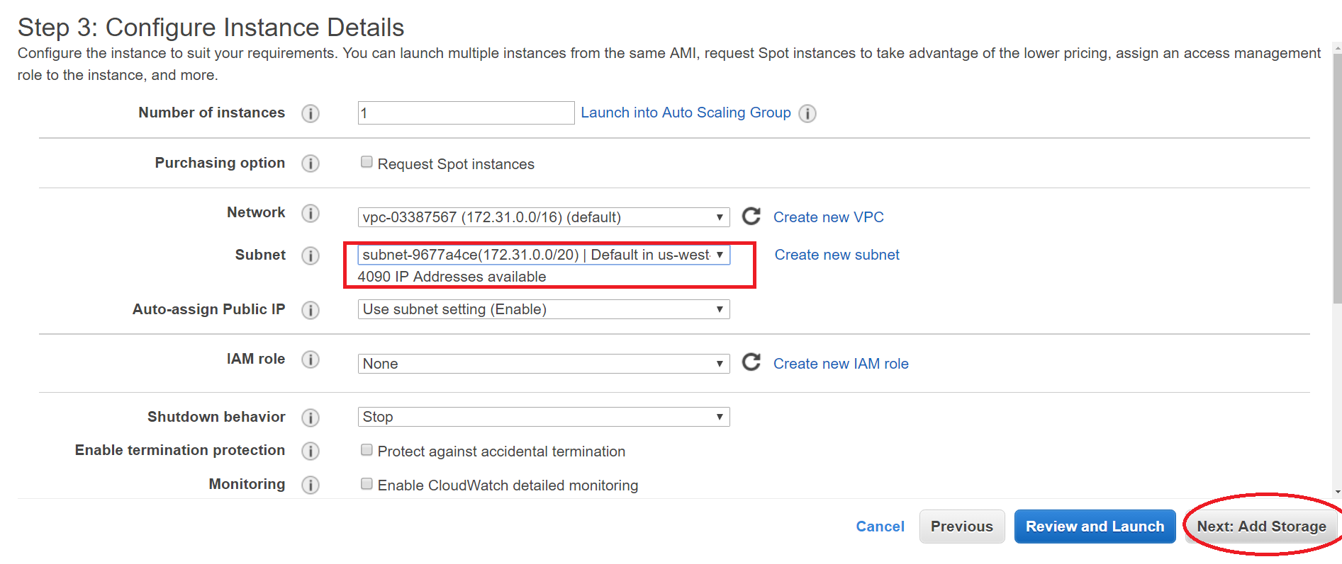

1. Enter the storage size and click next.

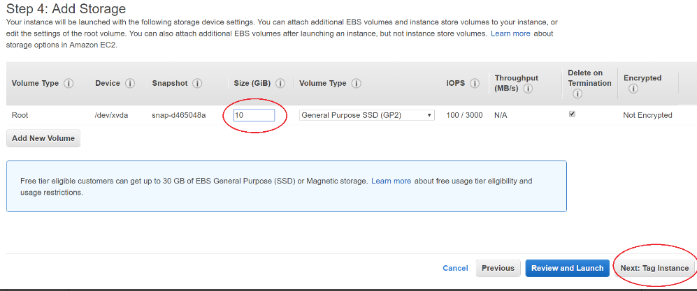

1. Give values to key and value, then click next

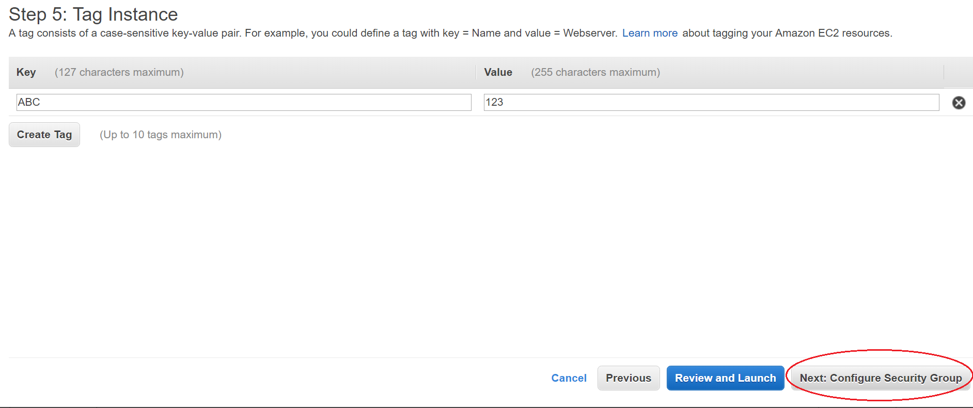

1. Add HTTP and HTTPS rules and click “review and launch”

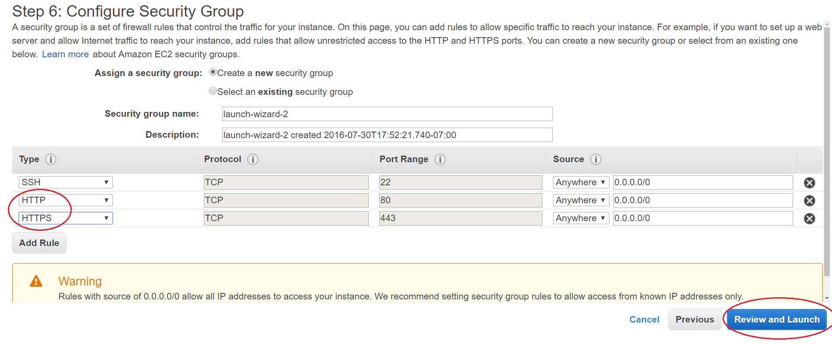

1. Click launch

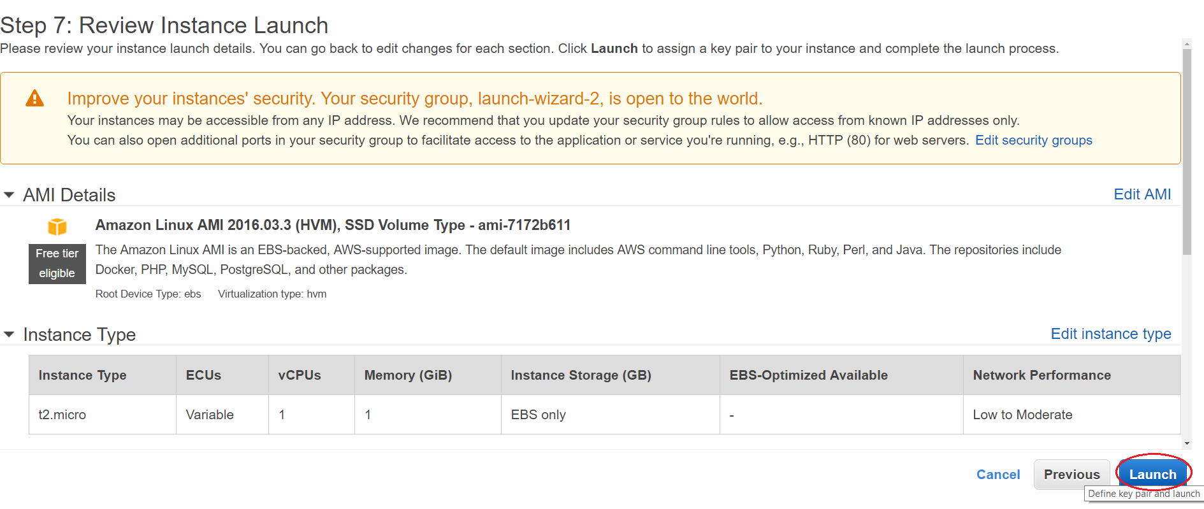

1. Select “create a new key pair” , give a name to key pair, click download key pair.(key pair will be downloaded) then click “Launch Instances”

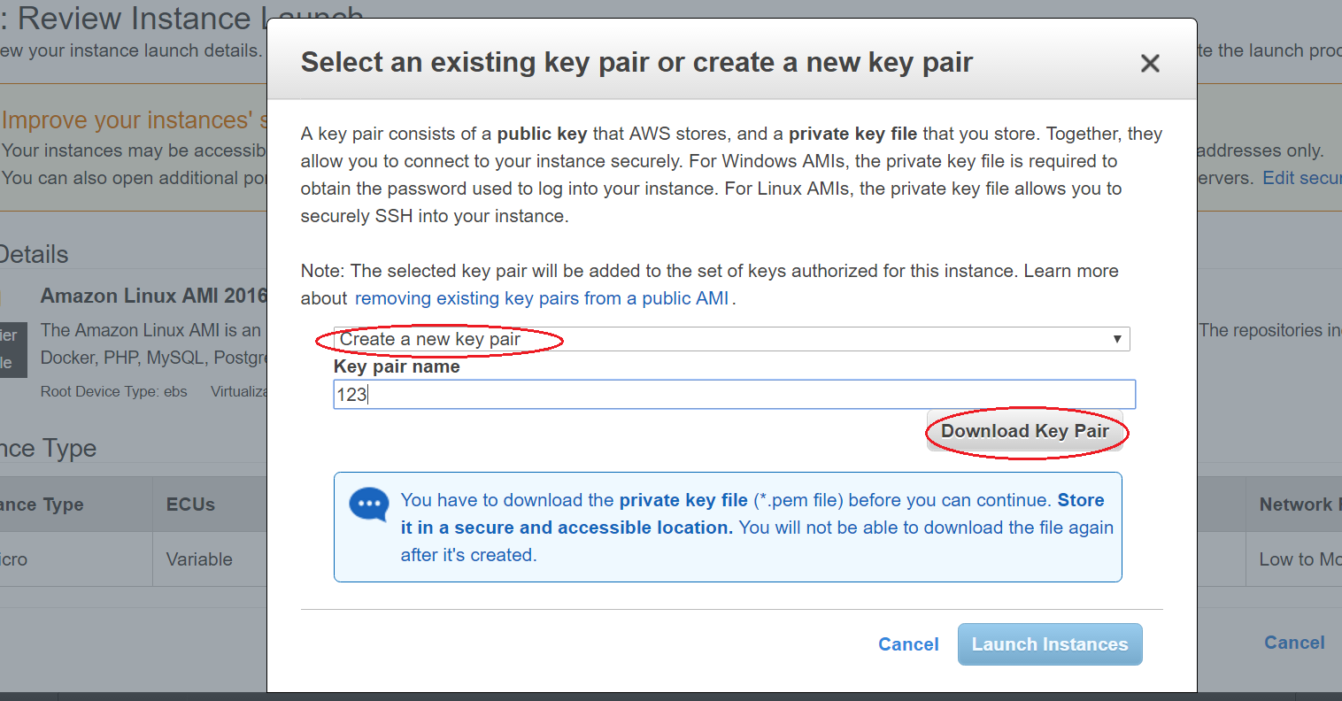

1. Select EC2 under services.

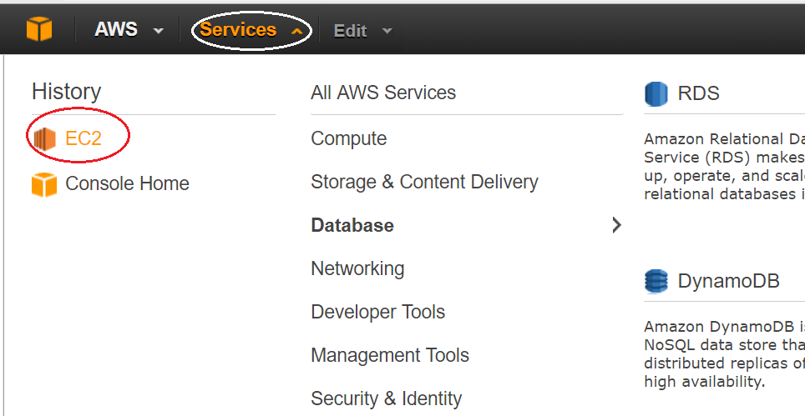

1. Click on “running instances”

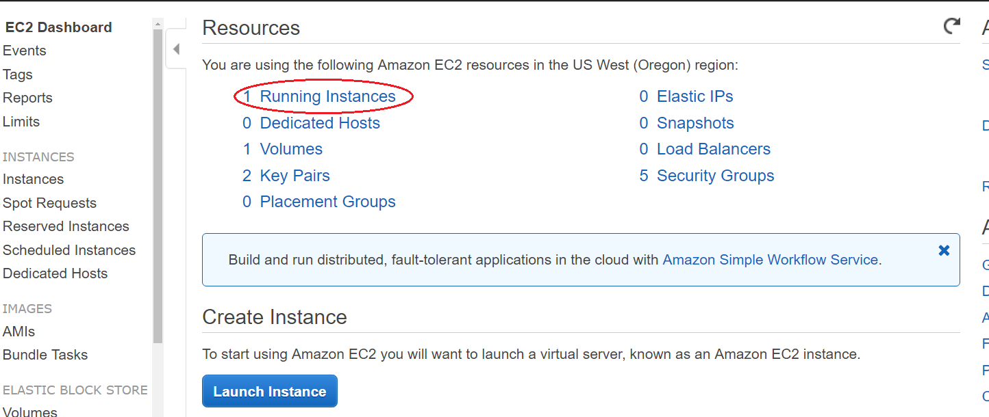

1. Download puttygen.exe and putty.exe
2. Run puttygen.exe

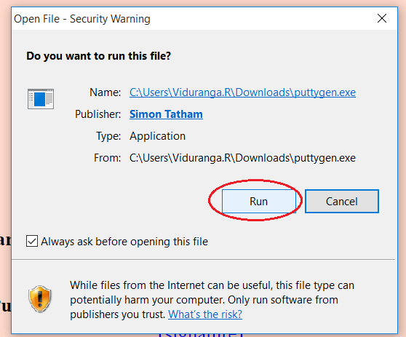

1. Select “Import Key” under conversions menu.

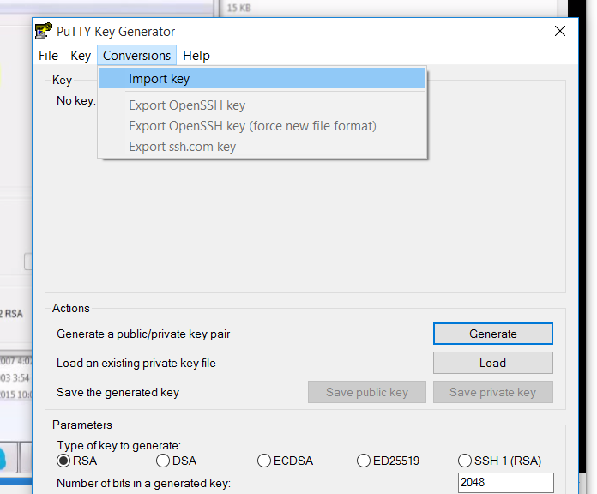

1. Click “Save Private Key” and give a name and save.

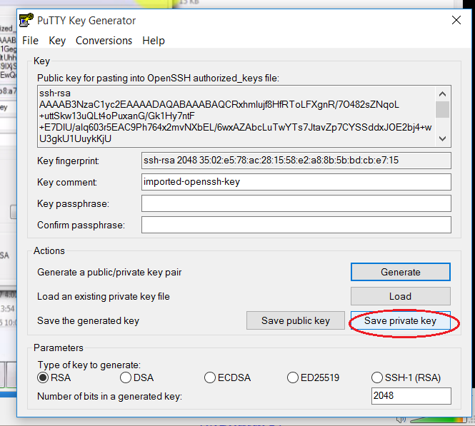

1. Run putty.exe
2. Select “Auth” under SSH.

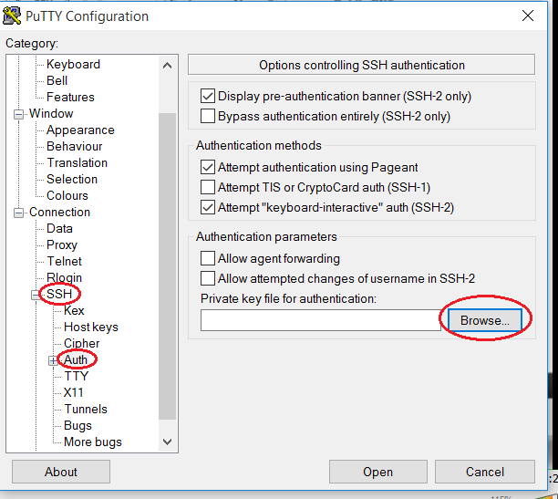

1. Click browse and select the file saved in step 18.

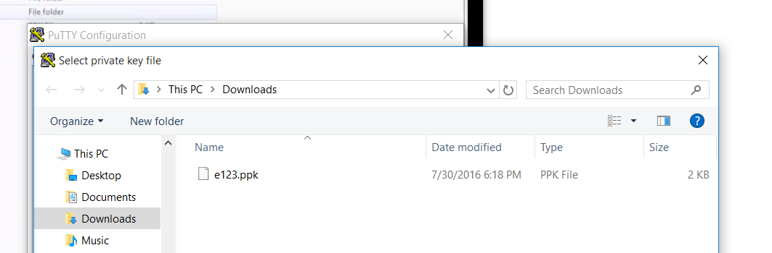

1. Click “Open” then Instance will start running.

**Creating an AWS windows instance**

1. Login to the aws account.
2. Select EC2 (virtual services in the cloud)



1. Select instances under instances from the left hand side menu



1. Now click on “Launch Instance”



1. Select Microsoft windows server 2012 R2 base

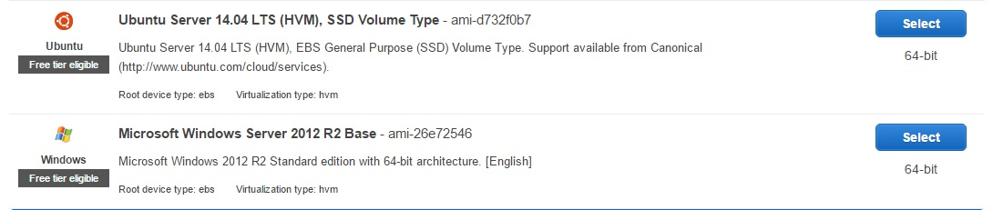

1. Click next

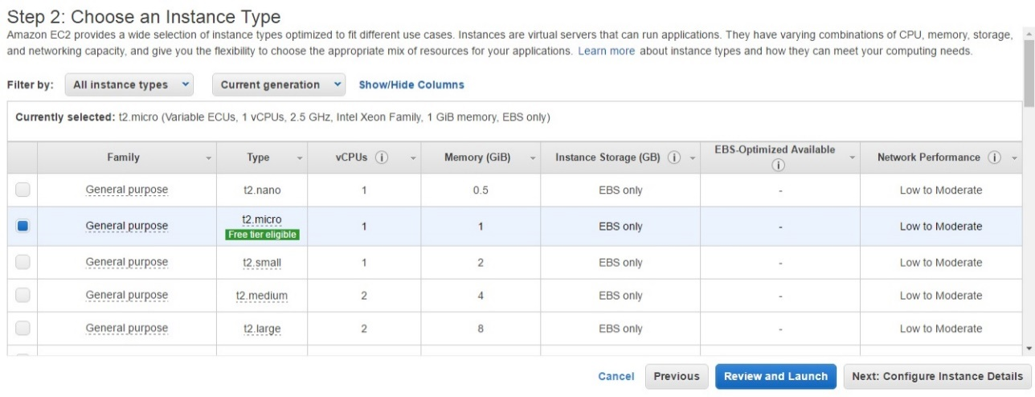

1. Click launch

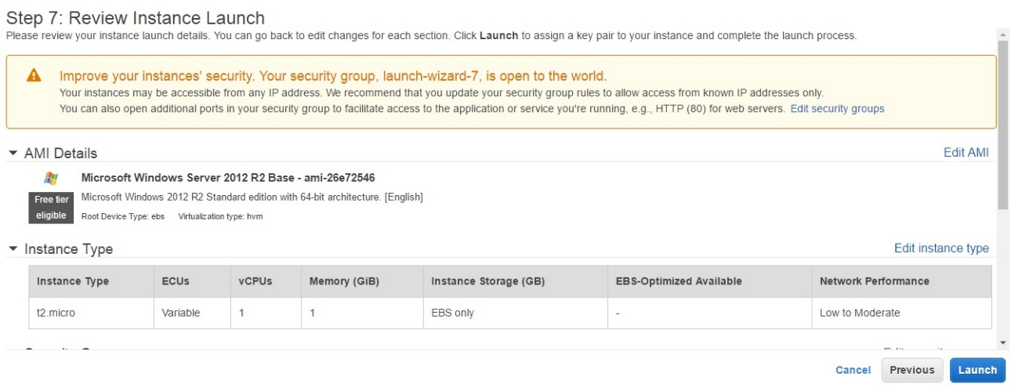

1. Select “create a new key pair” and give the key pair a name

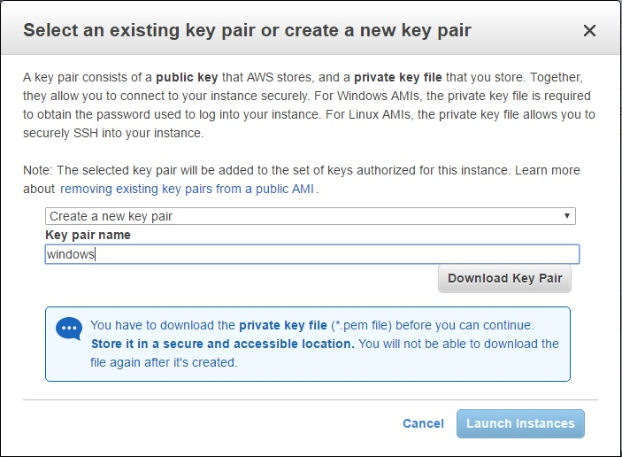

1. Download the key pair and click on “Launch instances”

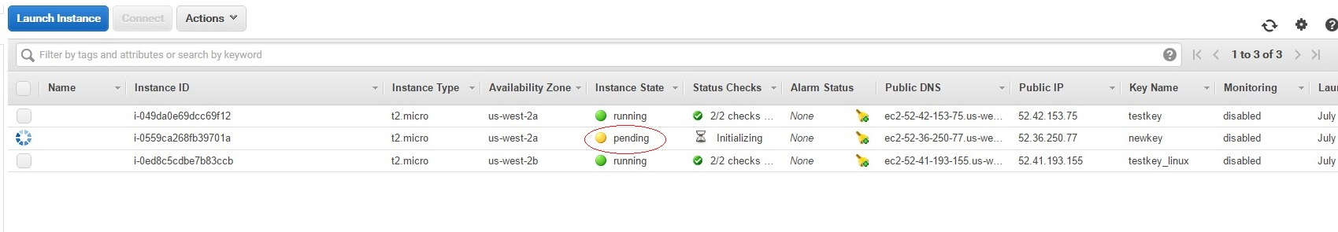

1. When the state of the instance changed in to running, click connect button.
2. Then click on “get password”

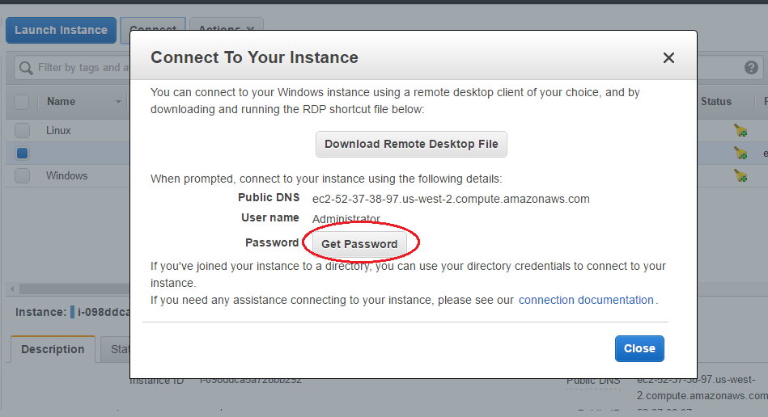

1. Then click on choose password and select the downloaded password and click decrypt password.

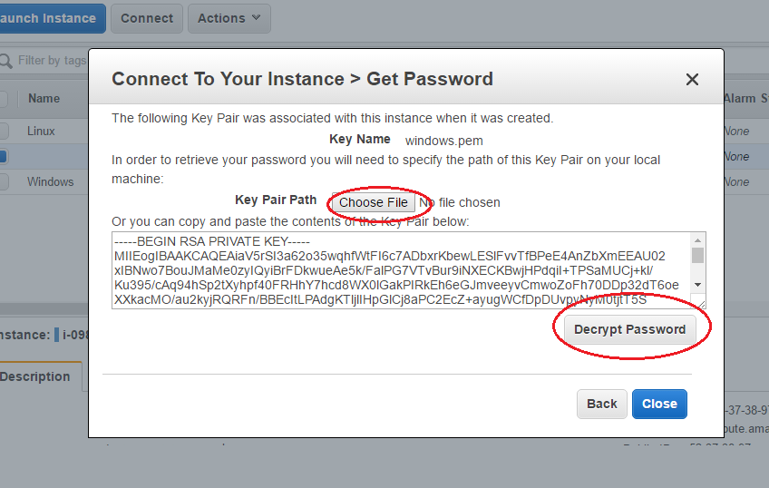

1. Then you can see the password, then click on “download remote desktop file”

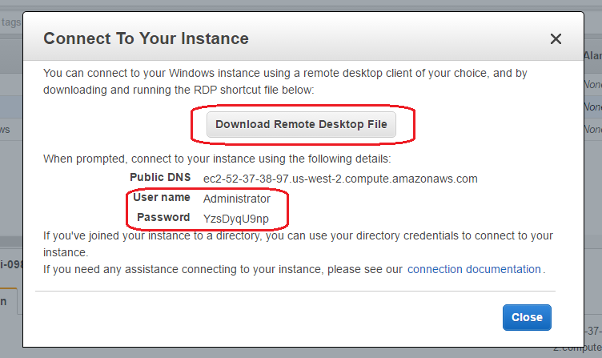

1. Open the file, click connect button

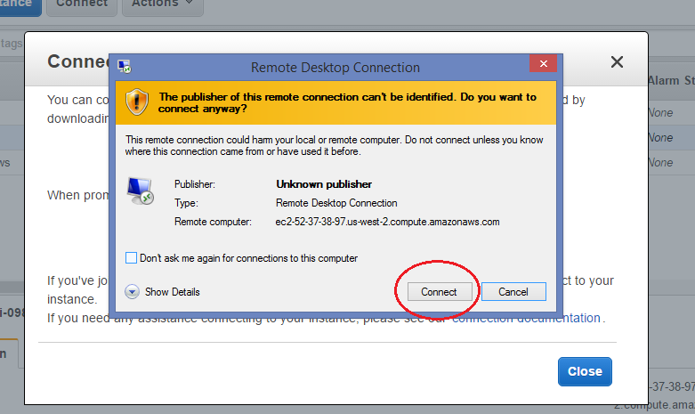

1. Give the password received in step 13 and click “OK”

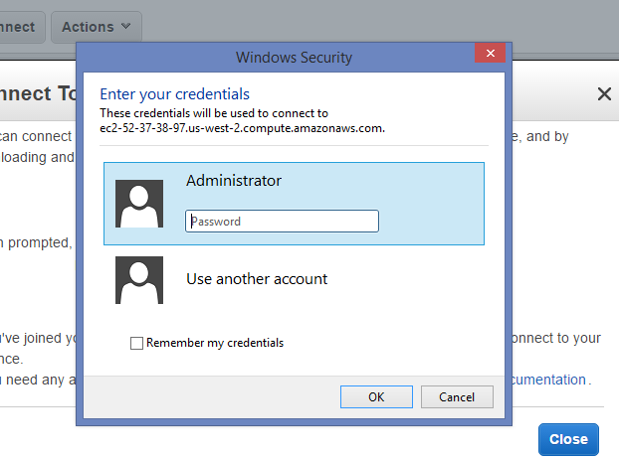

Then you will connected to the windows instance.

**Create a Database instance**

1. Select RDS under Database category

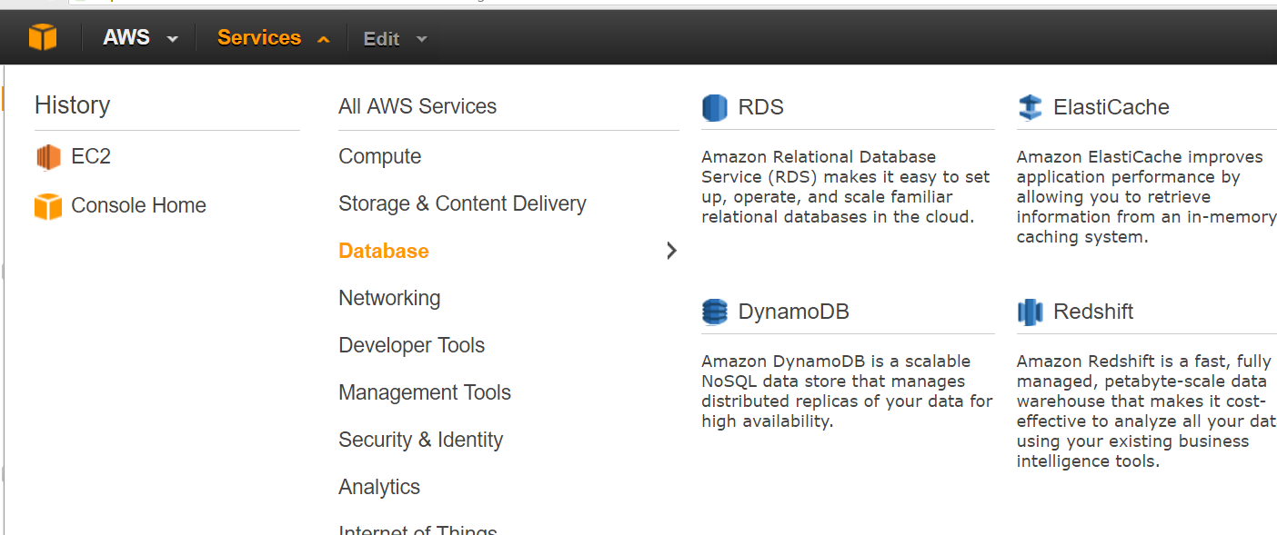

1. Click launch a DB instance button

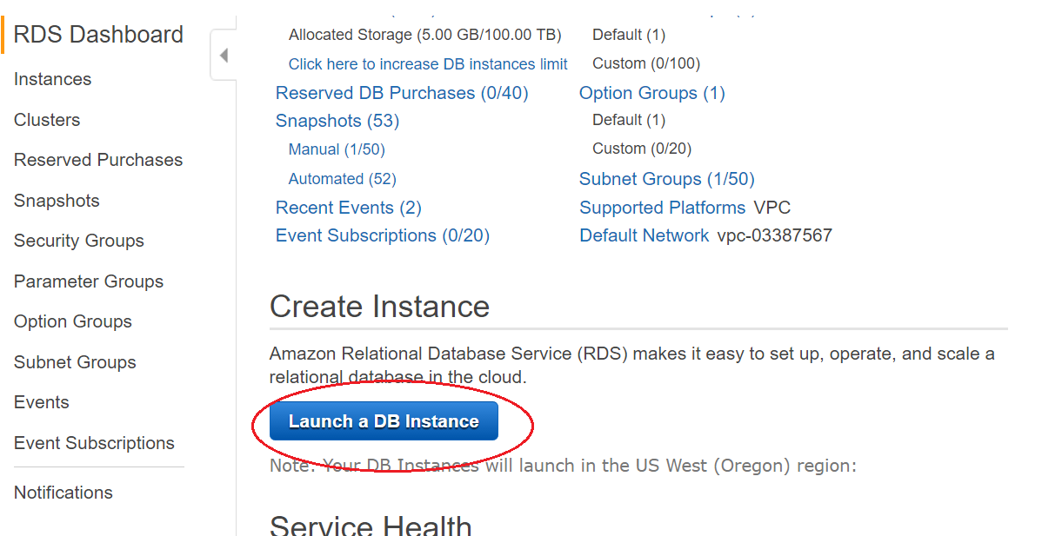

1. Select the DB type,(in this example MySQL)

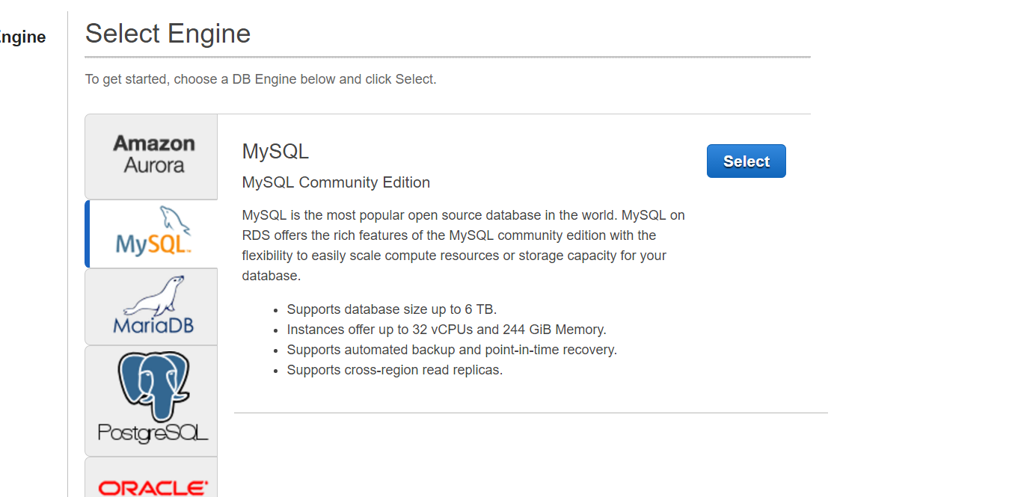

1. Select the MySQL radio button under Dev/test category

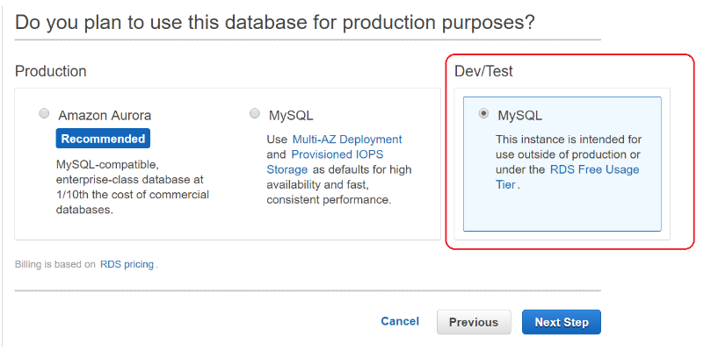

1. Select a db instance class, give storage size, and fill the fields rounded in red color and click “next step”

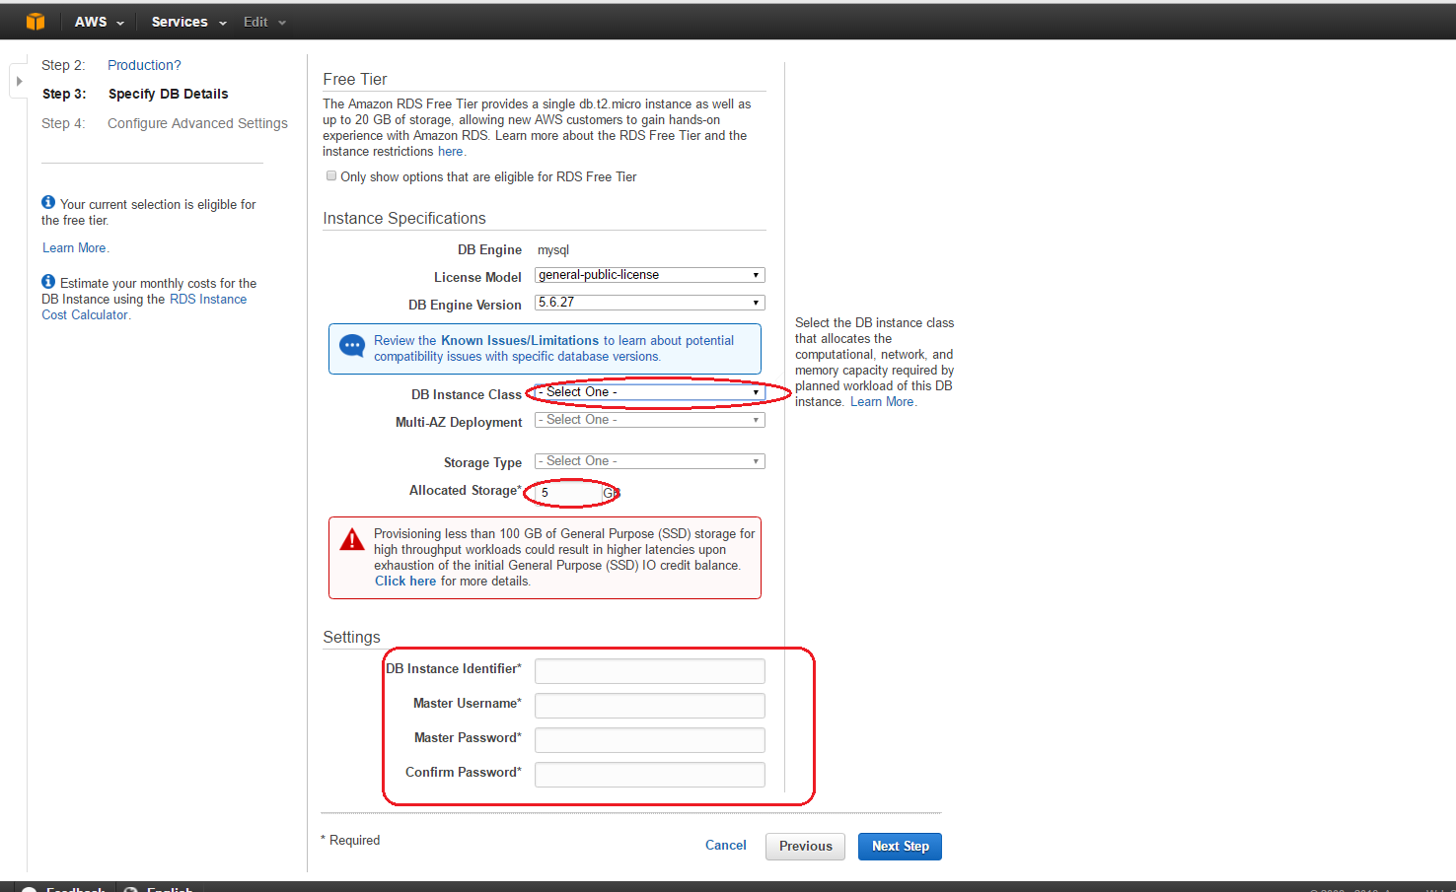

1. Keep all the default settings as it is. Then click on launch DB Instance

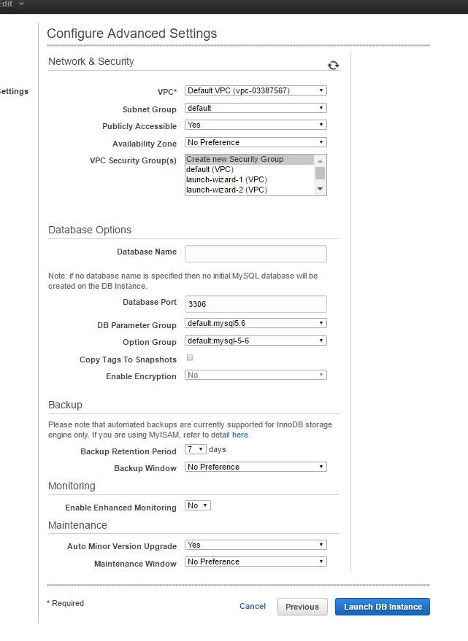

1. When click on view your DB instances, all the created db instances can be seen.
2. Copy the endpoint and save it somewhere it can be found easily

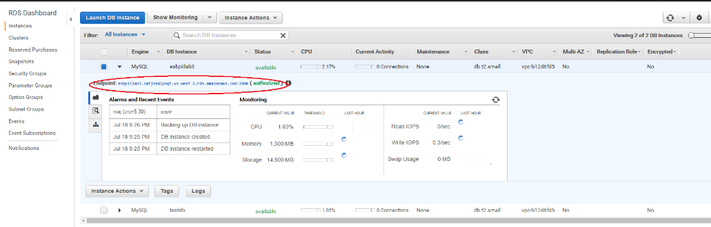

1. Open SQL Work Bench and select connect to databases under databases category and fill the fields in opening window.(host name is the endpoint copied before)

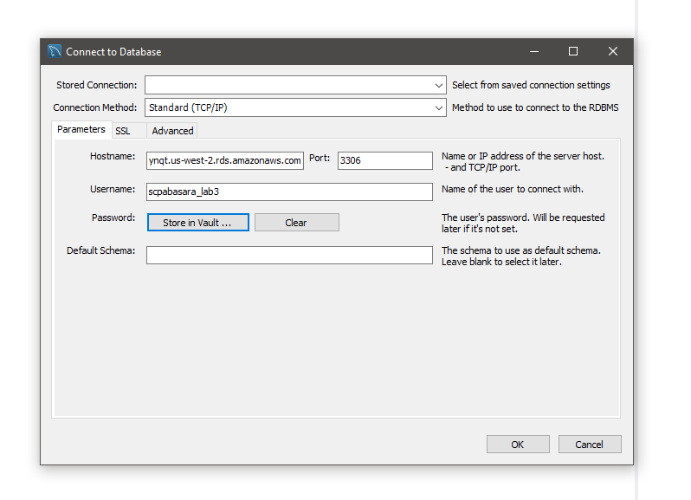

1. You have to enter the same password given in step5. Then you can connect to the db instance.